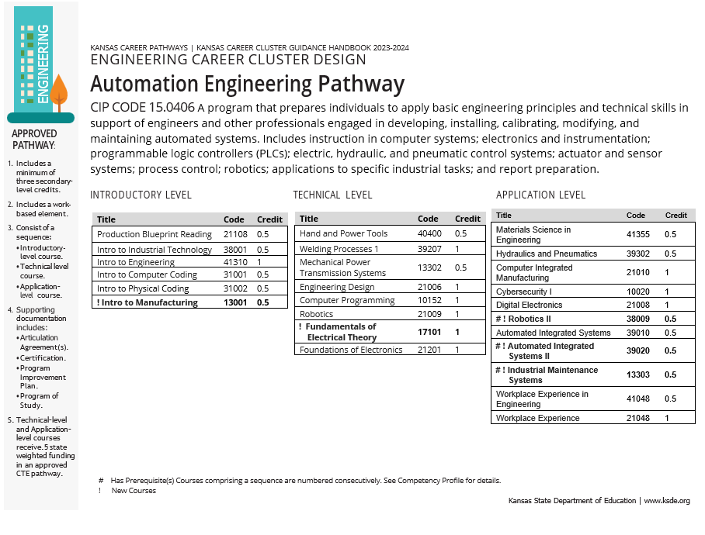
New Engineering Pathway

Pathway Recommendations Summary:

No Recommend Changes CTE Course Competencies and Indicators (ksde.org)

- Courses added to this pathway.

  - 21108 Production Blueprint Reading
  - 38001 Introduction to Industrial Technology
  - 41310 Introduction to Engineering
  - 31001 Introduction to Computer Coding
  - 31002 Introduction to Physical Coding
  - 40400 Hand and Power Tools
  - 39207 Welding Processes I
  - 13302 Mechanical Power Transmission Systems
  - 21006 Engineering Design
  - 10152 Computer Programming
  - 21009 Robotics
  - 21201 Foundations of Electronics
  - 41355 Materials Science in Engineering
  - 39302 Hydraulics and Pneumatics
  - 21010 Computer Integrated Manufacturing
  - 10020 Cybersecurity I
  - 21008 Digital Electronics
  - 39010 Automated Integrated Systems
  - 41048 Workplace Experience in Manufacturing
  - 21048 Workplace Experience

Courses Reviewed with Recommended Changes
  - No Courses Reviewed

New Course Recommendations.
  - 13001 Introduction to Manufacturing
  - 17101 Fundamentals of Electrical Theory
  - 38009 Robotics II
  - 39020 Automated Integrated Systems II
  - 13303 Industrial Maintenance Systems

